Qq1 1

Model Development Phase Template

|  |  |
| --- | --- |
| Date | 04 June 2024 |
| Team ID | SWTID1720451040 |
| Project Title | Ecommerce Shipping Prediction Using Machine Learning |
| Maximum Marks | 4 Marks |

**Initial Model Training Code, Model Validation and Evaluation Report:**

The initial model training code will be showcased in the future through a screenshot. The model validation and evaluation report will include classification reports, accuracy, and confusion

matrices for multiple models, presented through respective screenshots.

**Initial Model Training Code:**

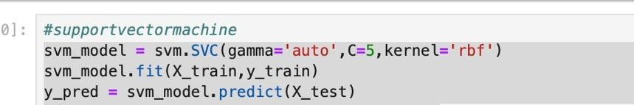**1)**

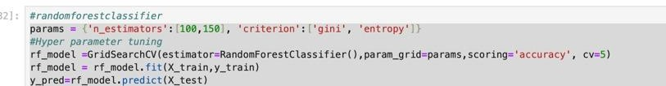

2

**3)**

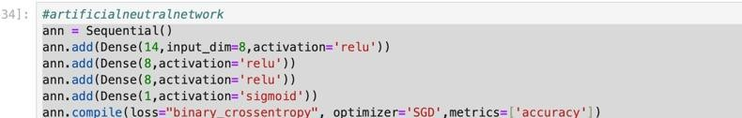

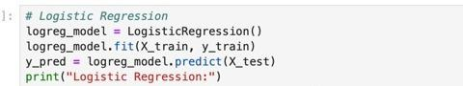**4)**

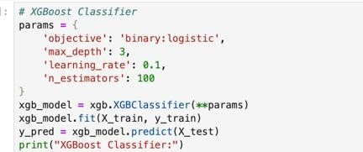**5)**

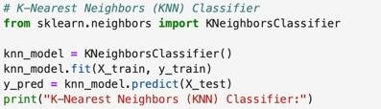**6)**

**Model Validation and Evaluation Report:**

|  |  |  |  |
| --- | --- | --- | --- |
| **Model** | **Classification Report** | **Accuracy** | **Confusion Matrix** |

|  |  |  |  |
| --- | --- | --- | --- |
| Support Vector Machine |  | 66% |  |
| Random Forest  Classifire |  | 67% |  |
| Artificial Neutral Network |  | 67% |  |
| Logistic Classifier |  | 64% |  |
| XGBoost Classifier |  | 69% |  |
| KNN  Neighbours Classifier |  | 65% |  |